**ASSIGNMENT 10:**

**Problem Statement: Deploy a project from GitHub to EC2 by creating new Security Group and user data.**

**Procedure:**

1. At first log into your AWS account, then go to EC2.

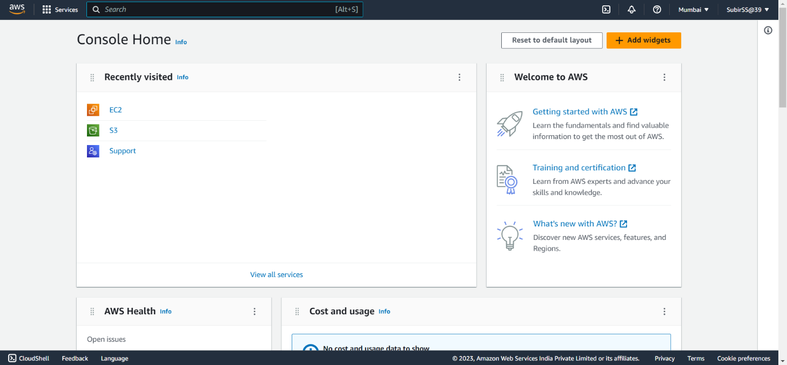

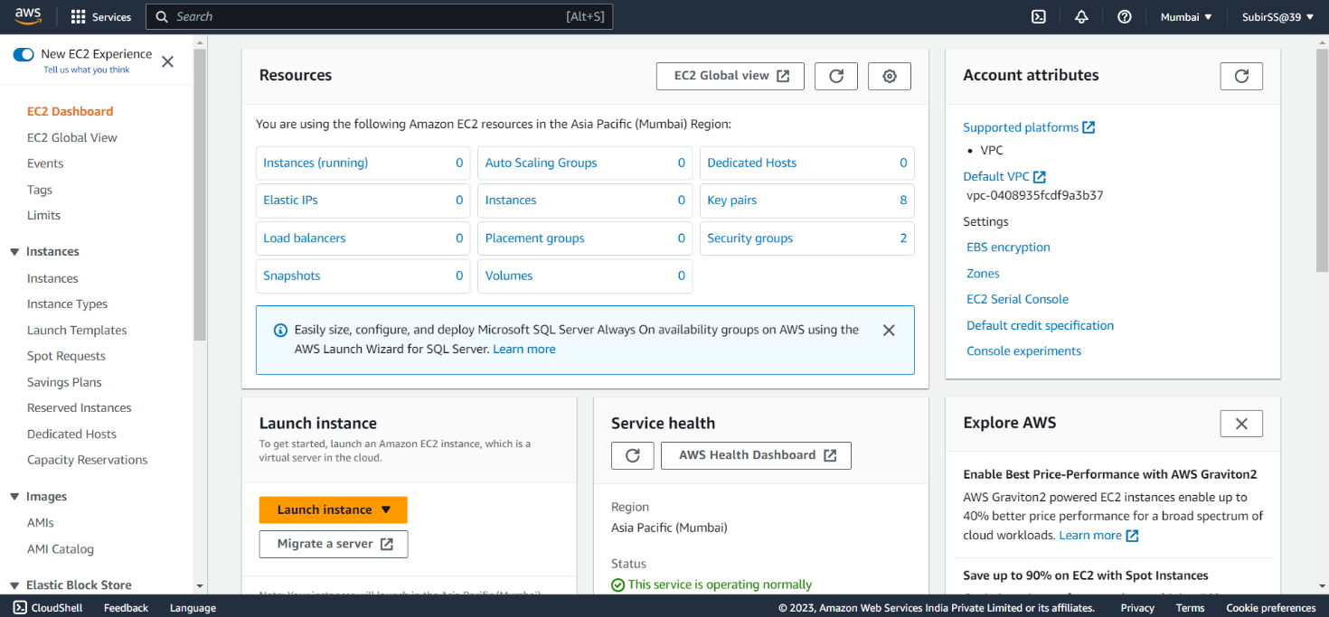

1. Then select Security groups.

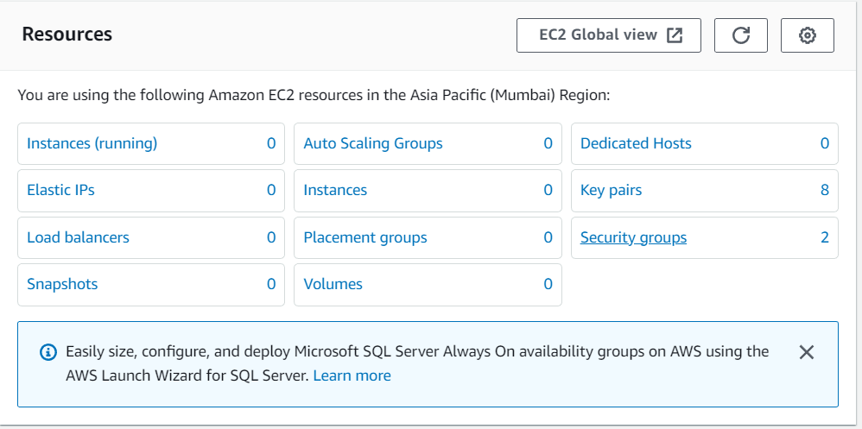

1. Delete the existing Security Groups except the default one.

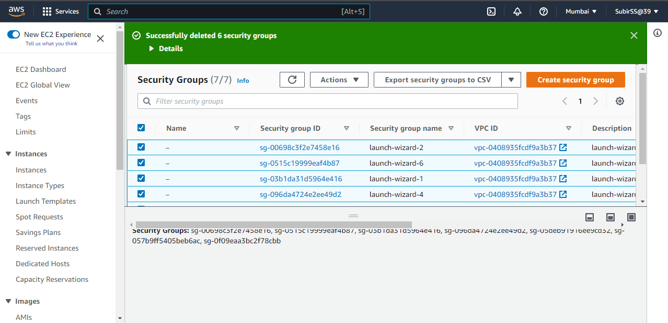

1. Then create a new security group with name, description etc.

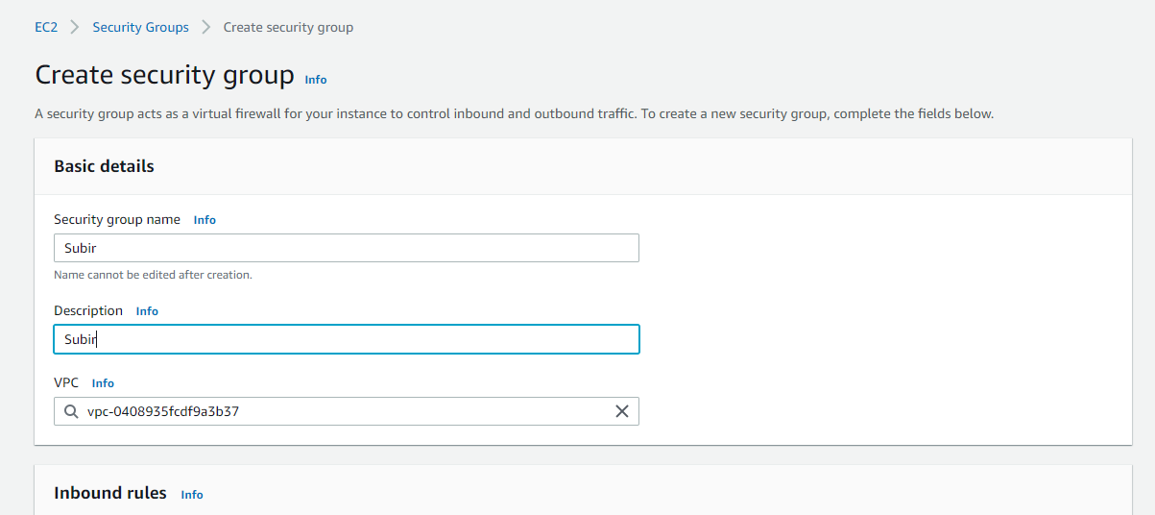

1. Set the Inbound rules for HTTP, HTTPS, and SSH as shown in the pictures.Set the Port Range of the Custom TCP as 4000.Then create the security group.

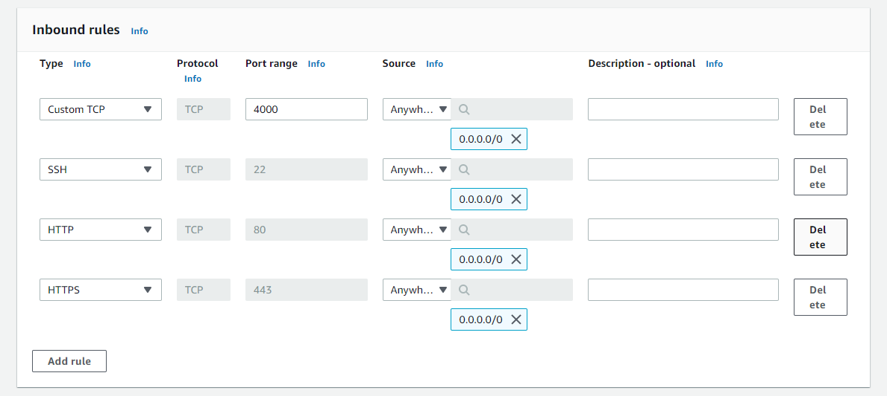

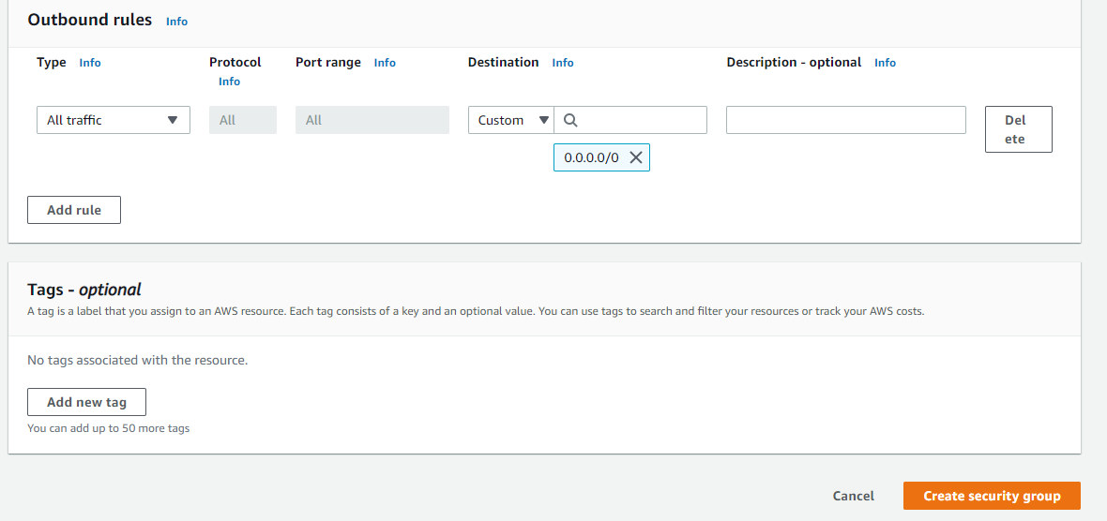

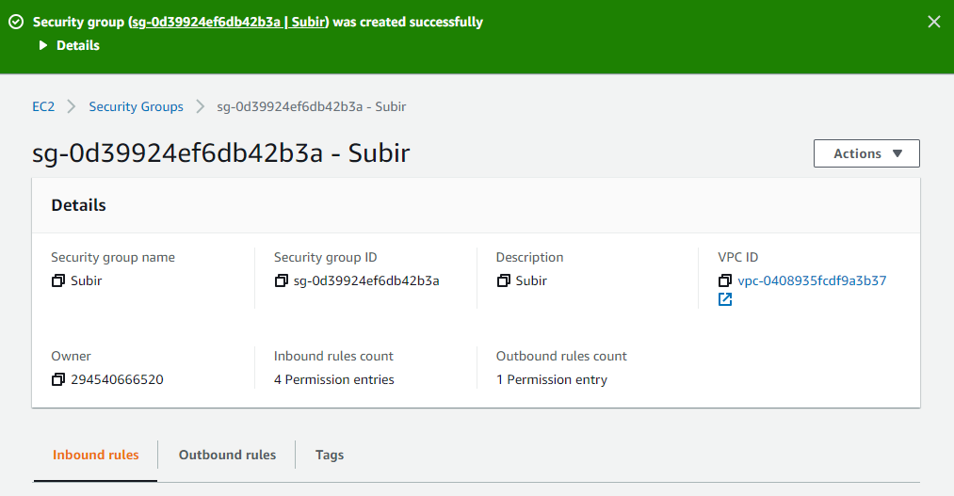

1. Then create an EC2 instance. In network settings, select existing security group and choose the created group.

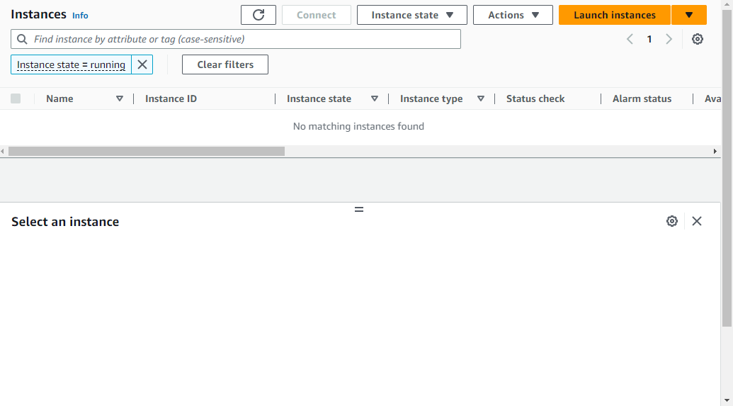

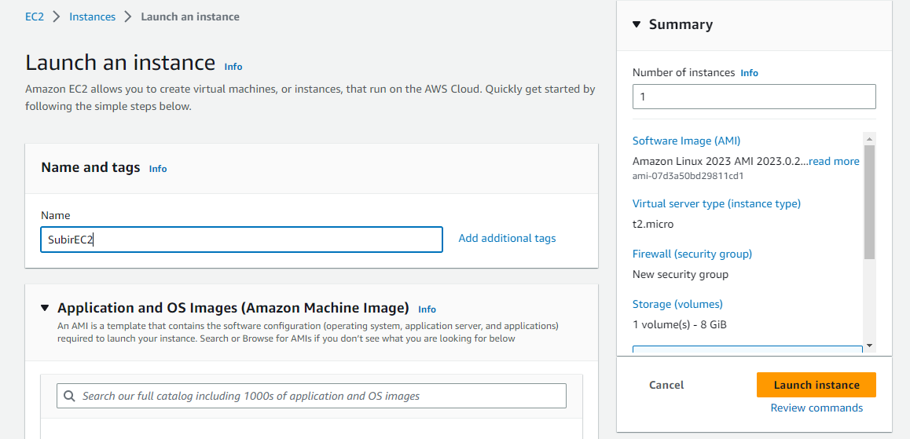

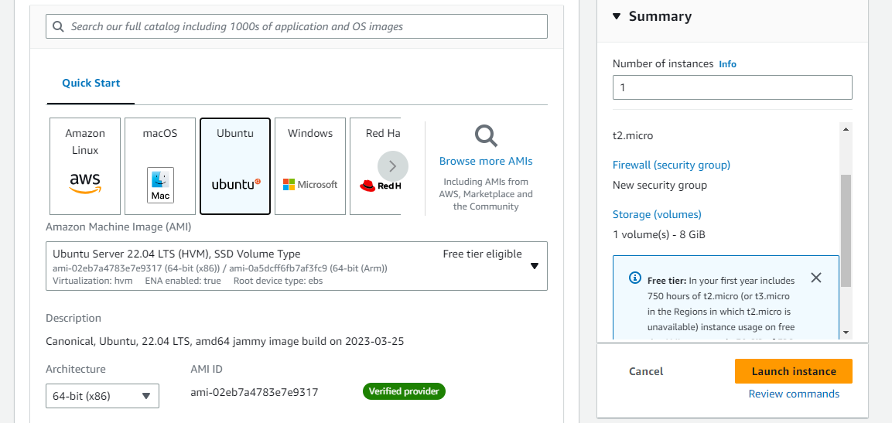

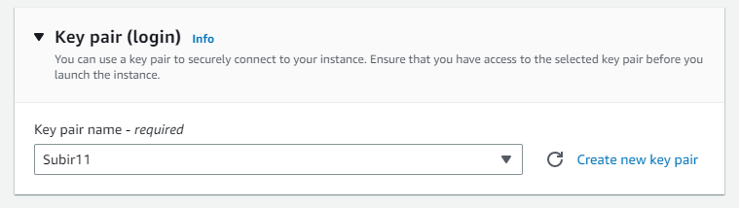

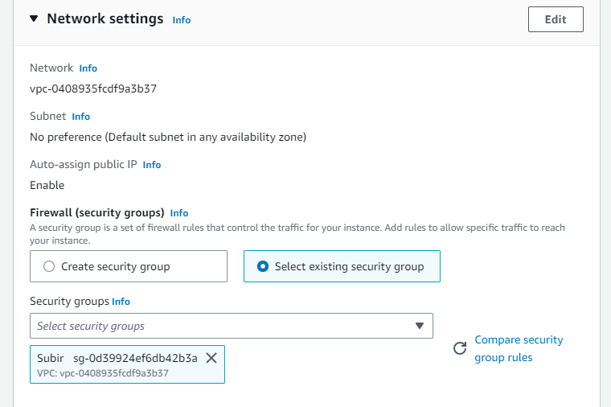

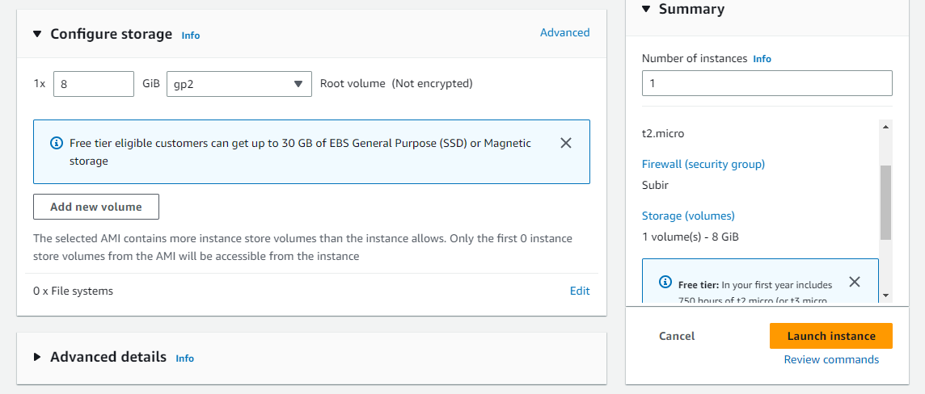

1. In advanced details, enter the following commands in ‘User data’ section-

**#!/bin/bash**

**apt-get update**

**apt-get install -y nginx**

**systemctl start nginx**

**systemctl enable nginx**

**apt-get install -y git**

**curl -sL https://deb.nodesource.com/setup_18.x | sudo -E bash -**

**apt-get install -y nodejs**

**git clone Repo link**

**cd Repo name**

**npm install**

**node index.js**

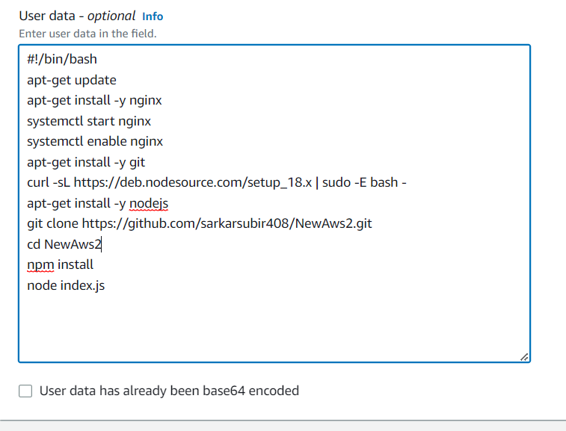

1. Launch the instance and then connect it using Bitvise SSH Client.

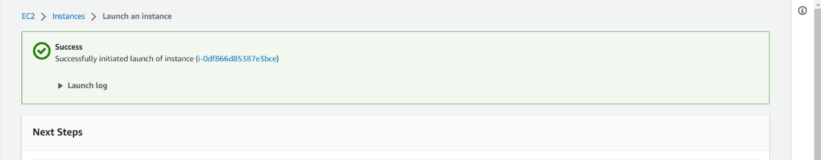

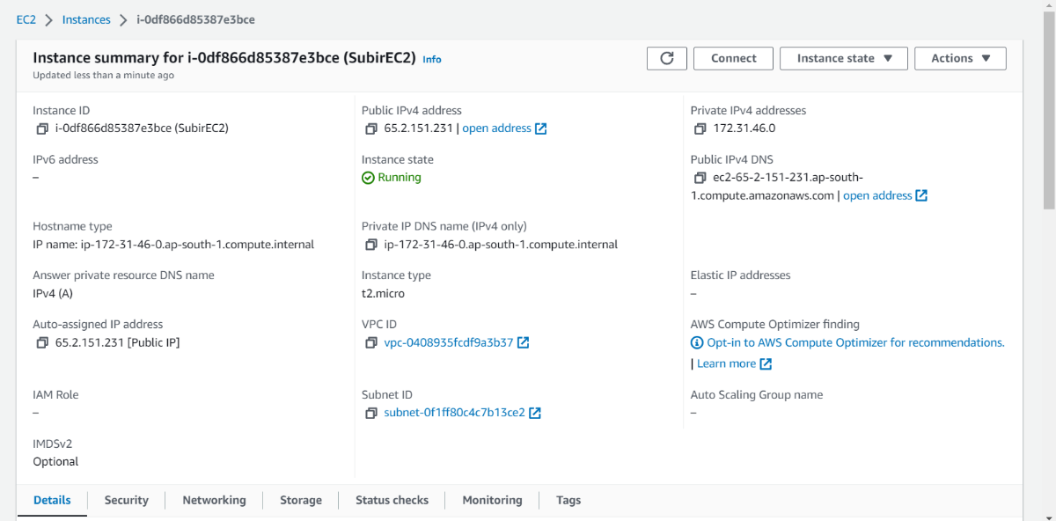

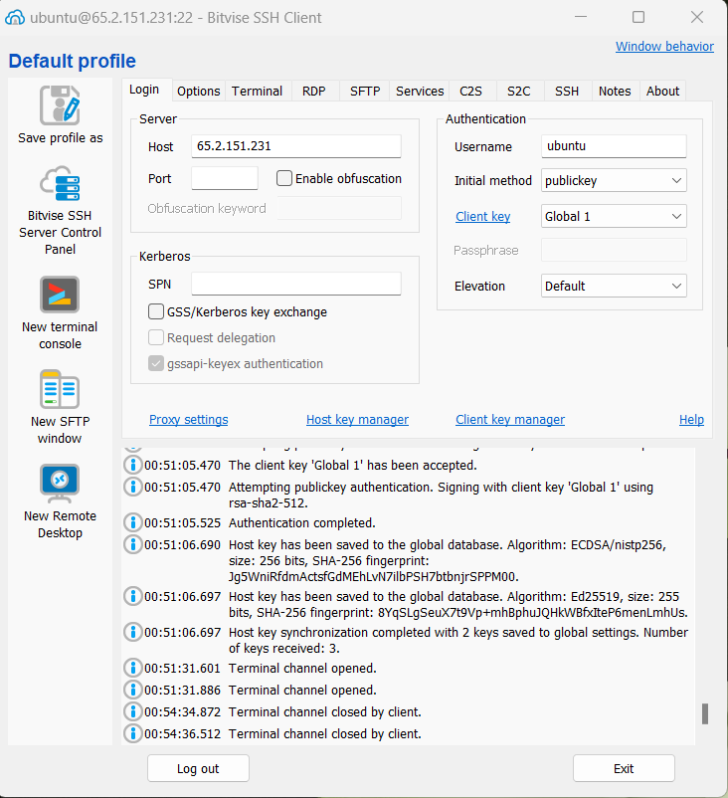

1. In New terminal console type the following commands-

**git clone repo link**(Here repo link is your GitHub’s repository link)

**cd repo name**

**npm install**

**node index.js**

(Give the username and password when prompted. Username is the GitHub user name and password is the token.)

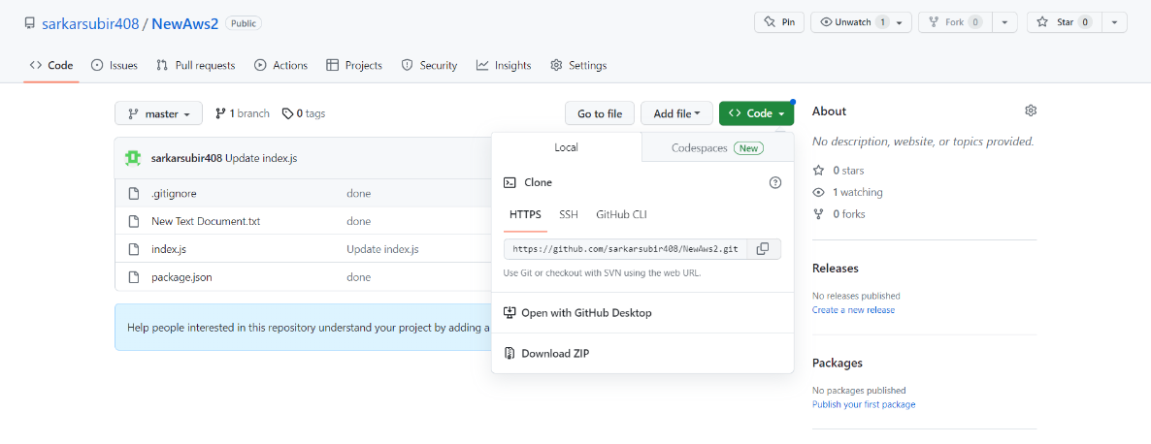

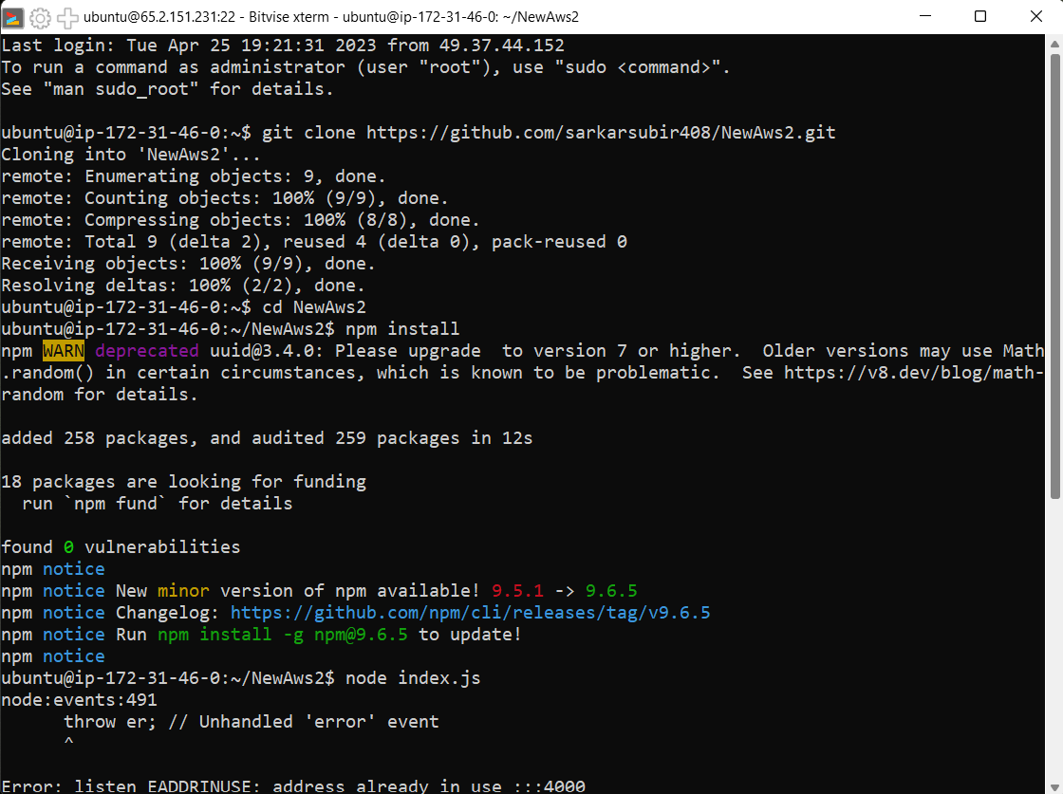

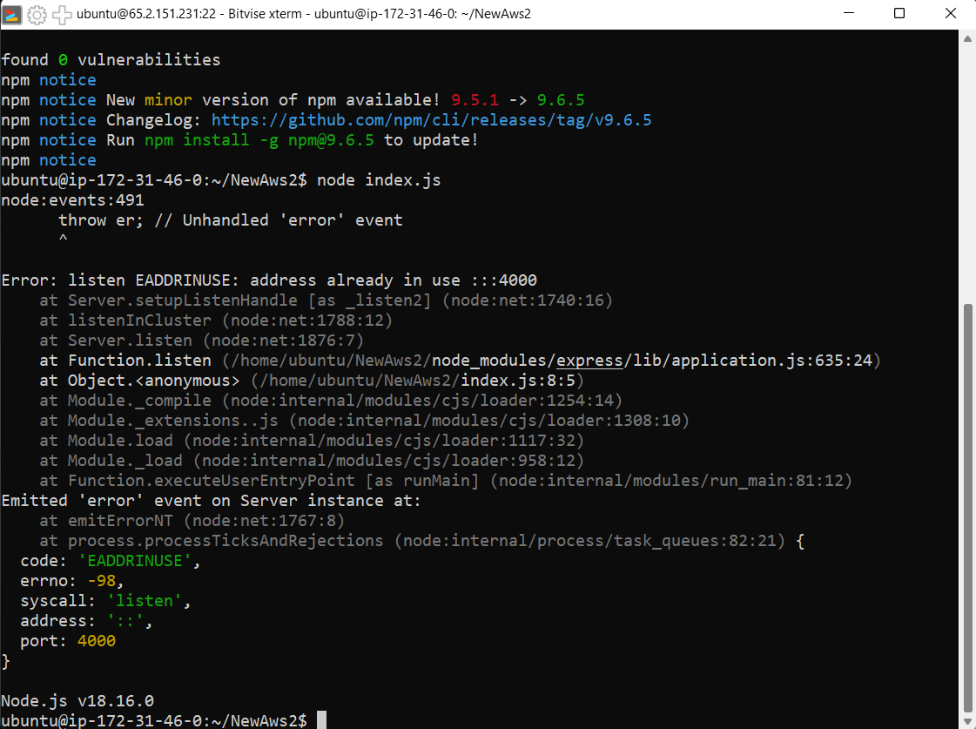

1. Now run the Public IPv4 Address with the custom port number in a web browser.

